Using Pivot tables and charts, perform the following tasks.

1. Which Region raked in the most Revenue?

Ans:Europe

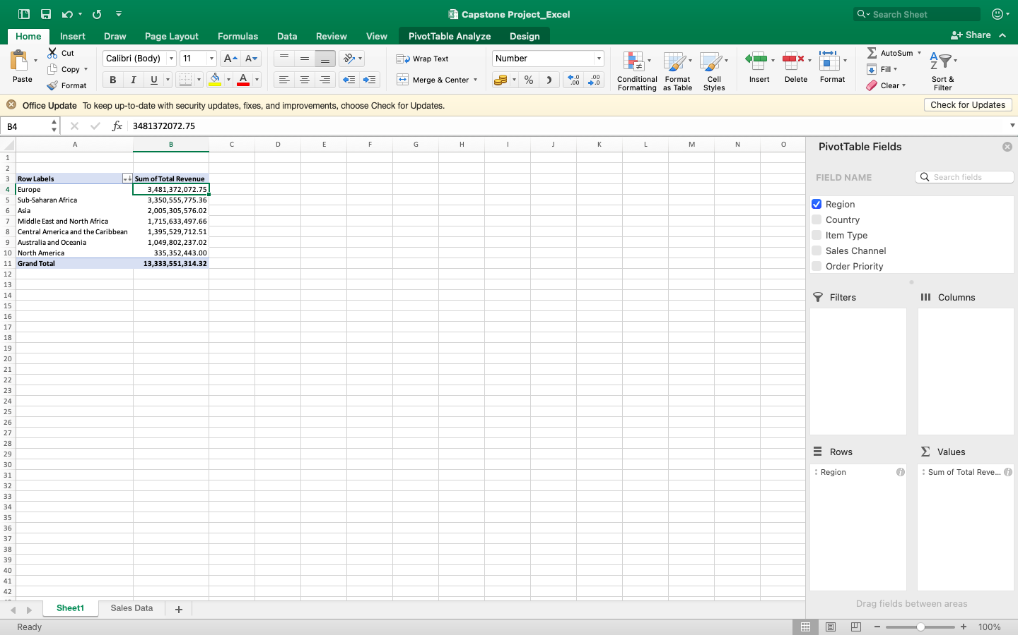

2. Who are the top five and bottom five Countries, based on profit?

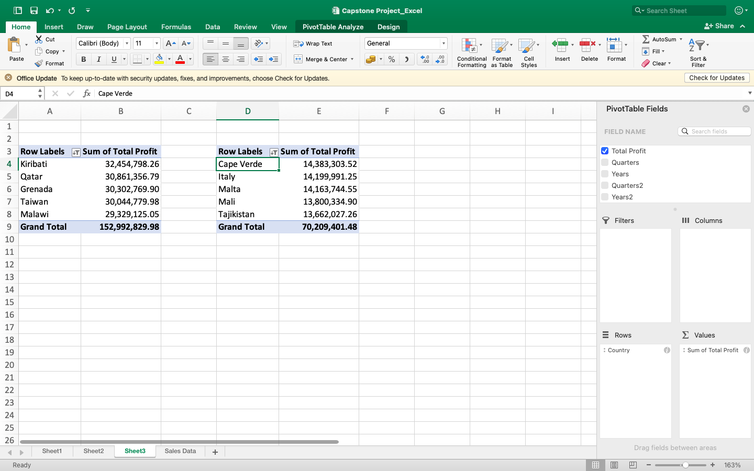

3. Display a line Chart of the Revenue by Region across the years, what was the

difference between the highest and lowest Regions.

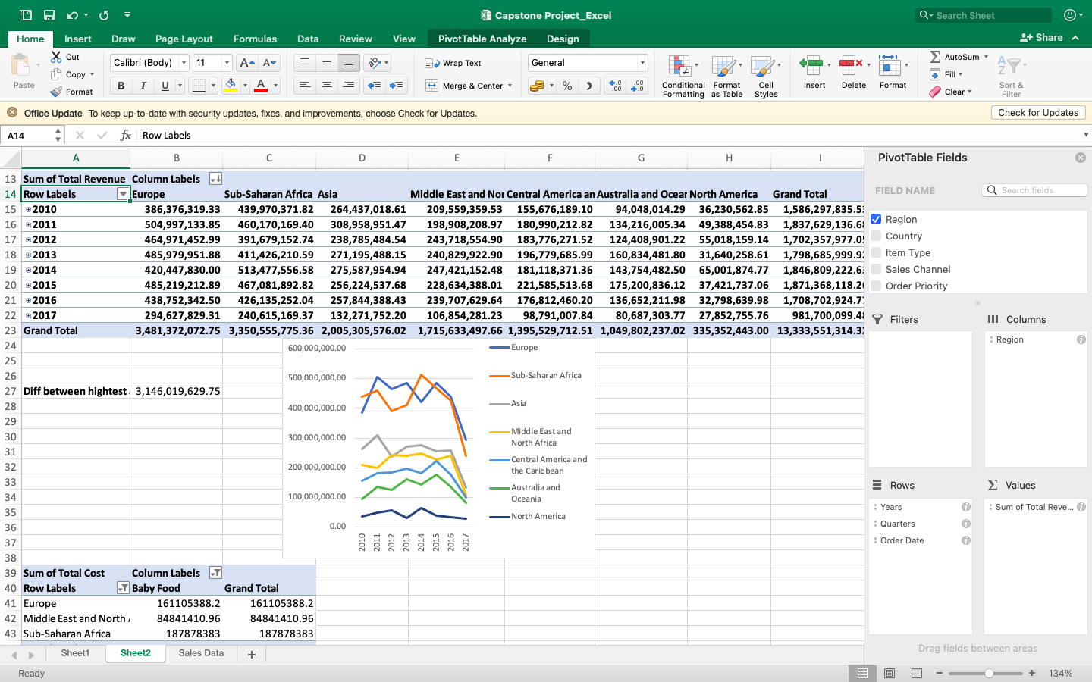

4. Compare the total cost of Baby Food items purchased by Africans and

Europeans.

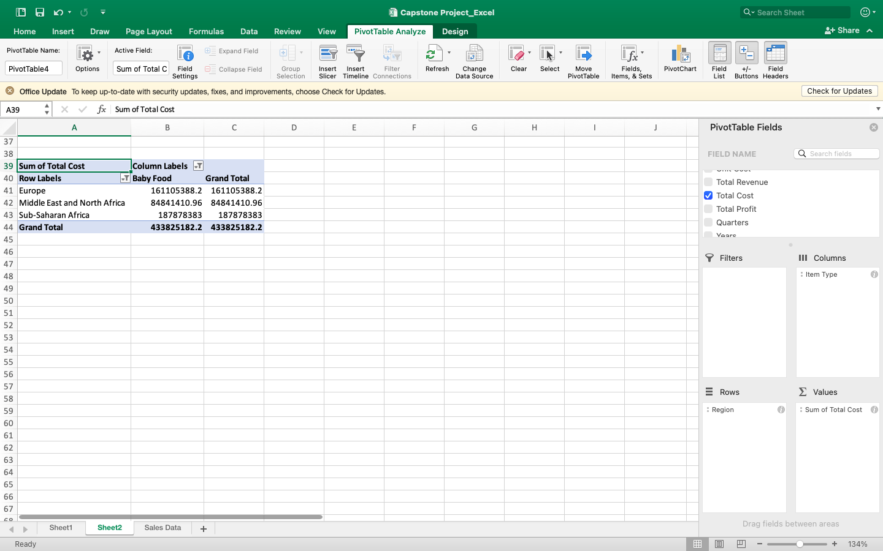

5. How many units of office supplies was sold to the Czech Republic?

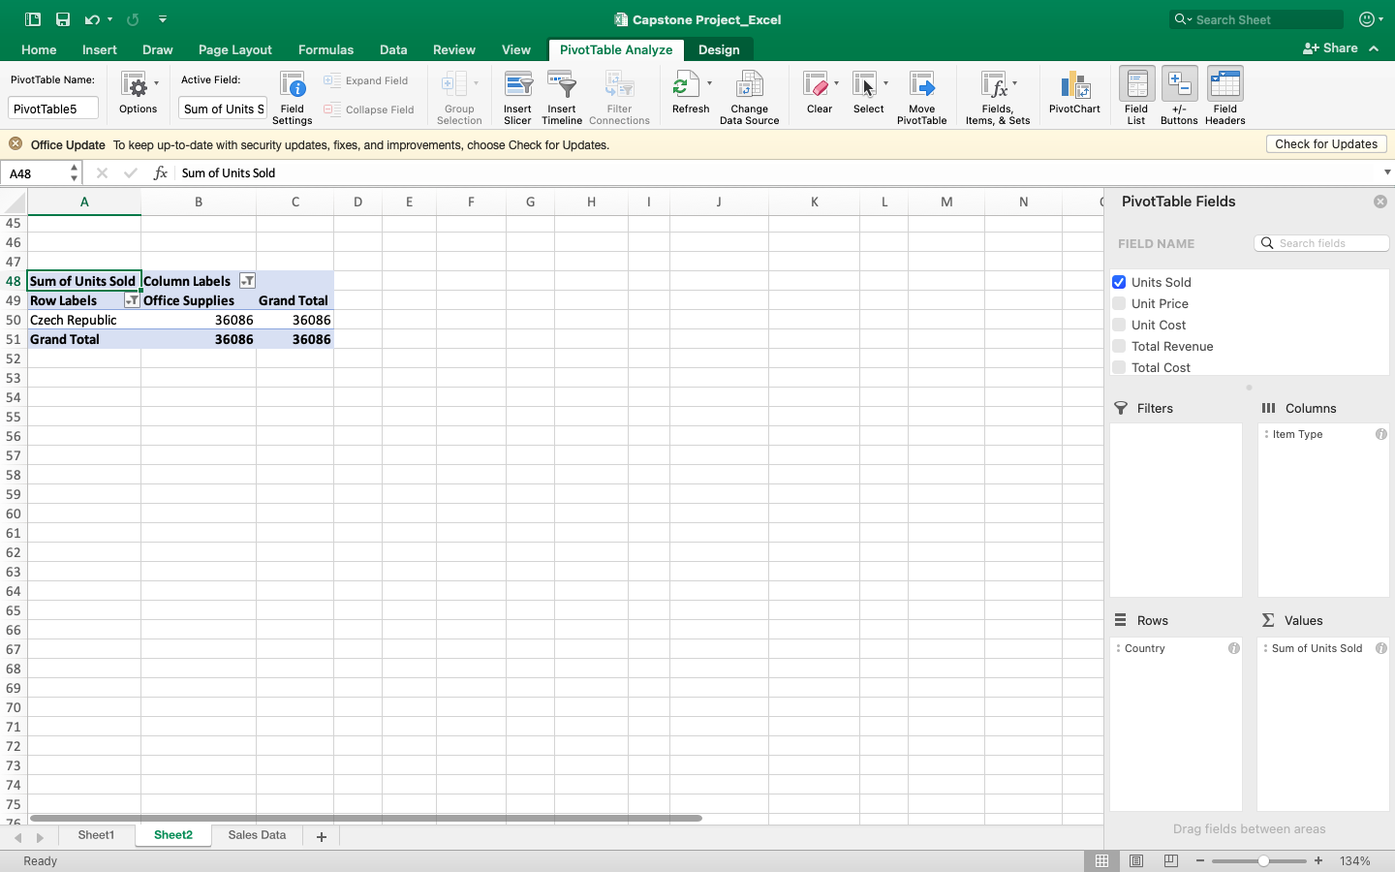

6. Which Country brought in the most Revenue between 2011 -2015?

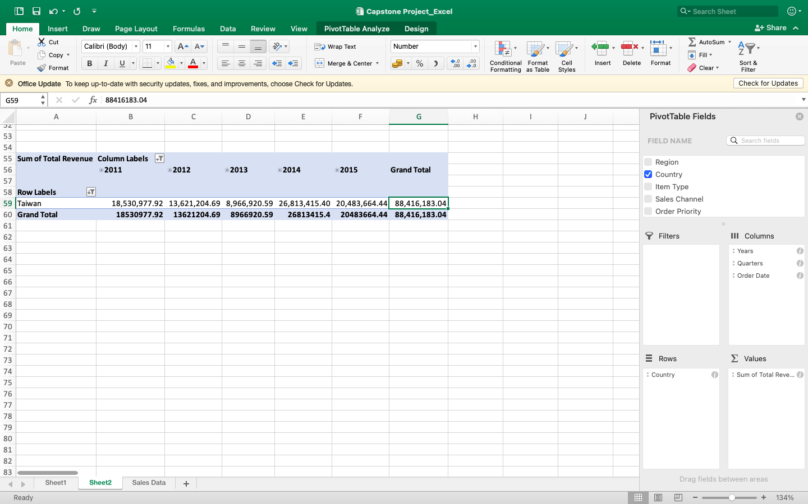

7. Which Region was the most profitable in 2015?

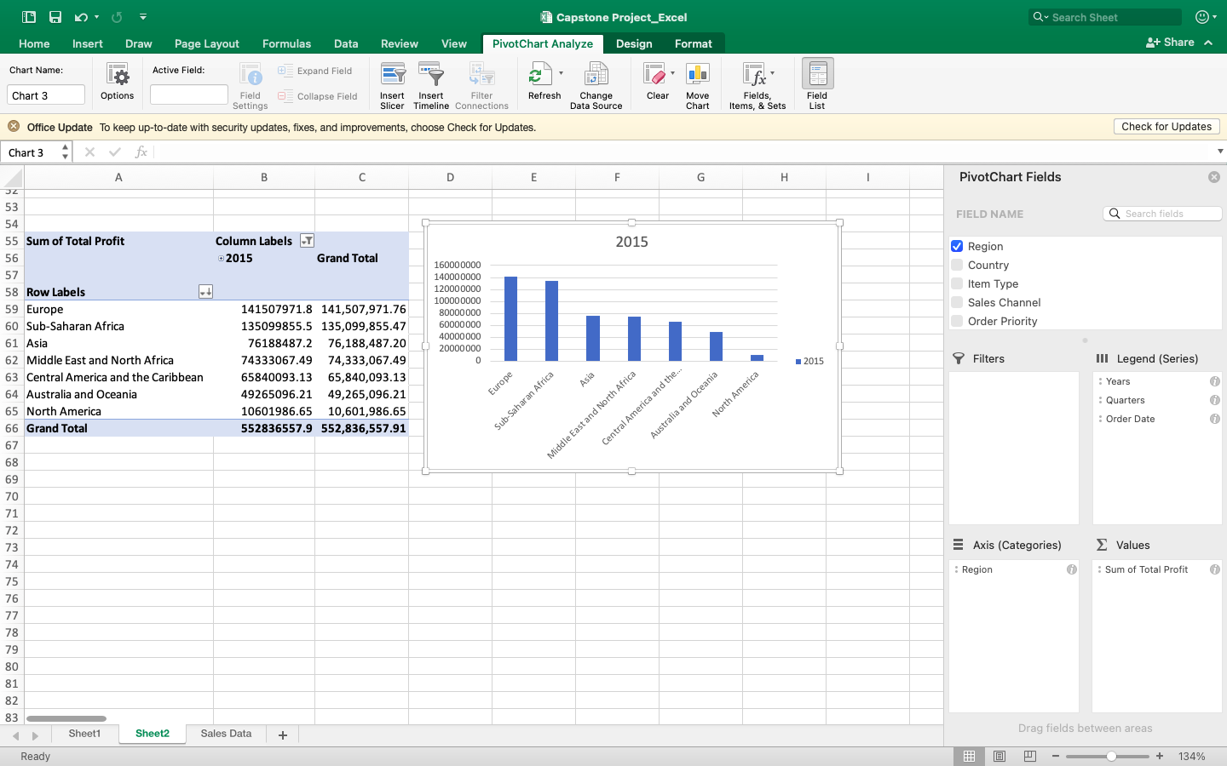

8. Which Country ordered the most item and what item did they order the most?

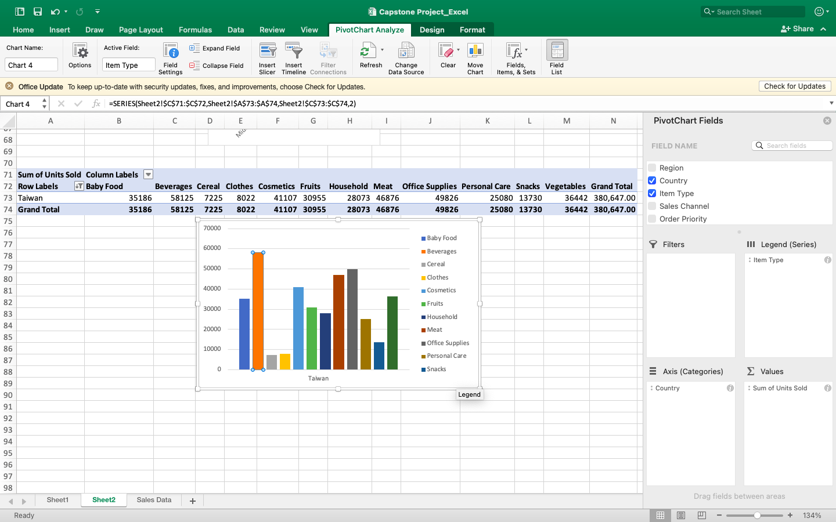

9. Which Region, and in turn Country was the least profitable through the Online

Sales Channel? Give hypothetical reasons why you think they performed poorly

through Online channel.

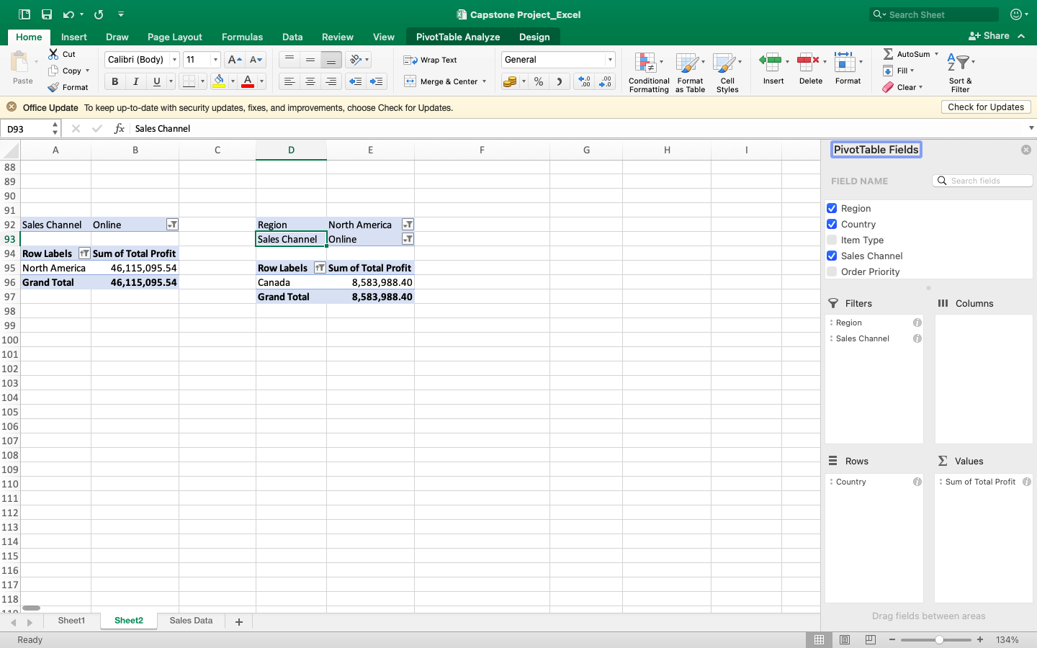

Ans: The offline orders for Canada generally has more priority

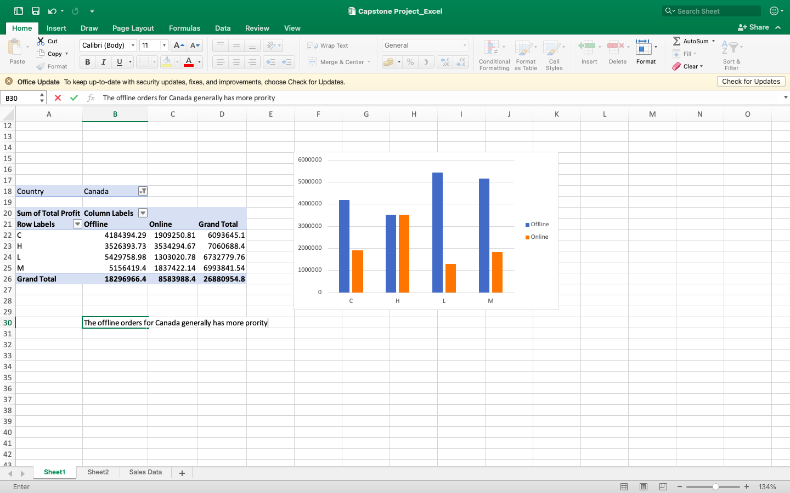

10. From which Asian Country did we get the most Profit in the Beverages item

type?

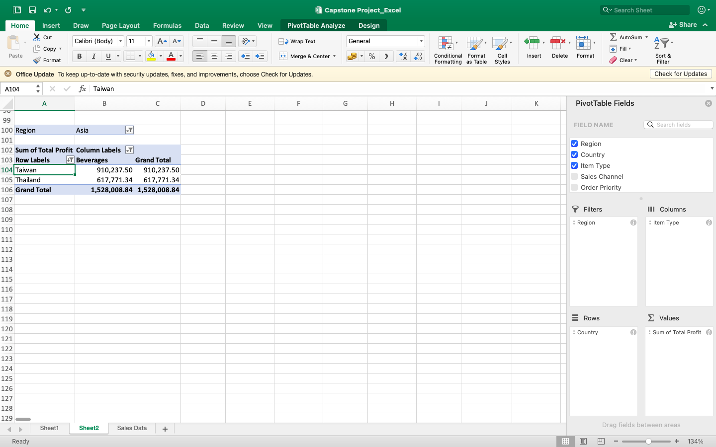

11. Compare the units of Fruits sold to Nigeria to the units of Snacks sold.

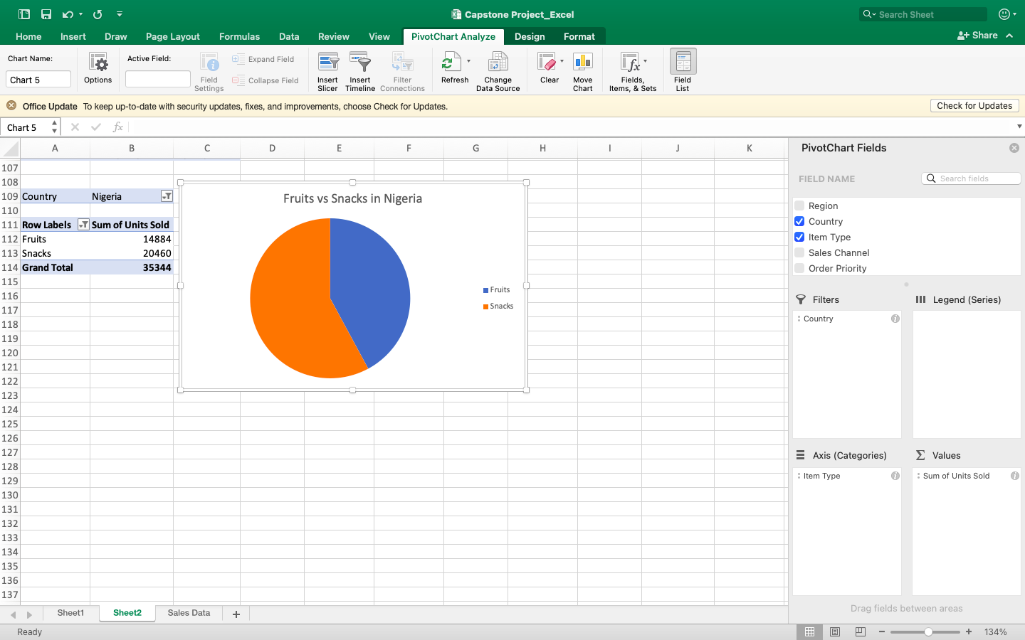

12. Looking at the data, what can you advise the Management to do to increase

patronage from the bottom five Countries?

Ans: The management needs to speed up their ship dates to increase patronage from the bottom five countries.